**Logbook Entry Window**

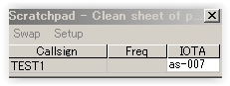

LBEW_44

## 10.0 FLOATING CALLSIGN FORM

Logger32 ~~ver 3.49.229 and late~~r has a Floating Callsign form. This form will display the current callsign that is posted in the Logbook Entry window "CALL" edit box. If you prefer it will be possible to configure to display his country name and local time with callsign.This window can be positioned anywhere on the screen(s) for handy reference for the current callsign being worked or checked for propagation. It can be positioned near the top of the Sound Card Data window or CW Machine window for quick reference. It is especially useful for users with 2 monitors.

To open the Floating Callsign form, place the focus in the Logbook Entry Window and enter the <**Ctrl+F**> key combination. You can also activate the Floating Callsign form with a right-click and select "Floating callsign field".

The following is a sample Floating Callsign form placed at the top of the screen just below the "Logger32" Title on the main MDI Form.

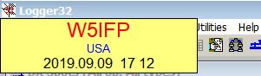

New LBEW_45

**Note**: The Floating Callsign window will be blank or hidden if there are no entries in the Logbook Entry CALL field.

The Floating Callsign window can be configured to the user's preference. A right-click on the window will bring up the configuration menus.

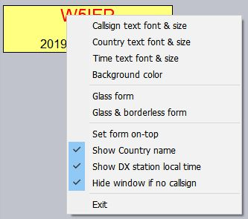

New LBEW_46

* 1. Text font & size: You can select "Text font and size". Vertical size of the form is adjusted automatically based on the Font size. The Floating form can be sized horizontally by dragging the sides with the mouse;
  2. Background color: You can select the desired background color when in a normal display mode. In the Glass form, the background is clear. (Transparent); and,
  3. Glass form: This option makes the form transparent displaying the Callsign with a border and no background color.

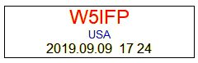

New LBEW_47

* 1. Glass & Borderless form: This option shows only the Callsign and is a little tricky to maneuver. In order to see this option, you must have a call in the Logbook Entry window CALL field. To get to the menu options, you must right click on one of the callsign letters or numbers. To reposition the form, you must Left click and drag the box with the mouse pointer positioned on one of the letters or number since it does not have a visible perimeter border.

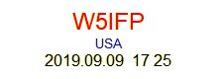

New LBEW_48

If you lose track of the Floating Callsign form, you can find it in the usual way. From the Logger32 Main menu, select the View | Find lost windows menu items. When the Currently open dialog box is displayed, check the "Floating" check box and then the <**Find**> button. This will disable the Glass mode and position the window in the Upper Left hand corner of the screen.

You can also find the FLoating Callsign form (if it gets lost, or the rubber band in your mouse is loose) by typing the <**Ctrl+F**> key combination a second time in the Logbook Entry Window, CW Machine, or Sound Card Data Window. This will disable the GLASS option, making the form more visible.

* 1. Hide window if no callsign: If this option is checked Floating Callsign form will be hidden when callsign field in Logbook Entry window is cleared.